[Salesforce Virtual Internship Program for Developer](https://www.ictacademy.in/salesforce-internship/" \t "_self)

A Report

On

Vehicle Management System Using Salesforce

Content

Introduction

Object  
Field and Relationship

Page and Layout setup

Lightning App

Profile

User

User Adoption

Report and Dashboard

**Introduction:**

The **Vehicle Management System using Salesforce is an application designed to streamline the managements of customer details and facilitate the selection of cars, bikes, and commercial vehicles for travel within a city. The system stores customer information and utilizaes it for various purposes, including notifying customers about seasonal offers and sending updates related to vehicles via message and emails.**

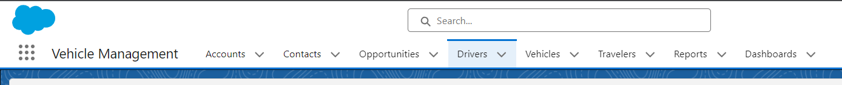

**OBJECT:**

Salesforce objects are database tables that permit you to store data that is specific to an organization. Salesforce objects are of two types: Standard Objects: Standard objects are the kind of objects that are provided by salesforce.com such as users, contracts, reports, dashboards, etc.

**Standard Objects:**Account, Contact, Opportunity.

**Custom objects:** Vehicle, Driver, Traveler.

Accounts:

Contact:

### Fields And Relationship

An object relationship in Salesforce is a two-way association between two objects. Relationships are created by creating custom relationship fields on an object. This is done so that when users view records, they can also see and access related data.

Driver:

Opportunity table:

